Warwickshire GAA statement: Pairc na hÉireann redevelopment

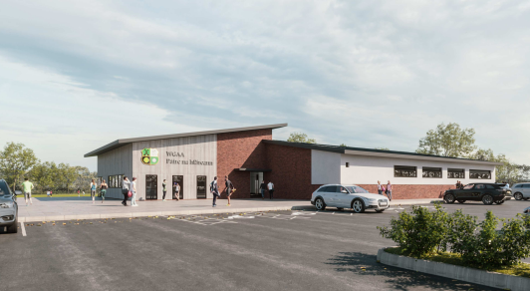
Proposed new clubhouse and dressing rooms
England and Aston Villa star Jack Grealish has thrown his support behind the campaign to save a key West Midlands grassroots sports facility.

Páirc na hÉireann (Ireland Park) is home to Warwickshire Gaelic Athletic Association and the thousands of people from across Birmingham, Coventry and Wolverhampton who enjoy Gaelic football, hurling and camogie. The site plays host to a range of sports, cultural, health and well-being activities for young people as well as regular amateur sport for adults.

The organisation’s 3,000 volunteer members in the region were left reeling when it transpired that major work on the M42 at Junction 6 would see a road run right through the current site of its pitches, clubhouse and a memorial to its deceased members. However, after a campaign led by the local GAA supported by the huge Irish community in the West Midlands, plans to relocate and rebuild these much-loved and vital facilities were agreed with Highways England.

Next week (Wednesday 11th August), a crunch meeting of Solihull Metropolitan Borough Council is due to decide whether to approve the plans.

Warwickshire GAA Chairperson Michael Collins said: “Planning permission has been deferred twice now and a further deferral or rejection would prove catastrophic for us. Any appeal process could take over 12 months to complete.

“Highways England has stated that they will commence work immediately after the council’s 11 August planning meeting, regardless of the outcome.

“Such a scenario would mean that we would be left with barely one full size pitch and an uncertain future.

Warwickshire GAA has already agreed and outlined ambitious plans to open the new facility to the local people of Solihull Borough and has had numerous expressions of interests from sports clubs and schools already.

“For us to move forward as an amateur sporting organisation we need the certainty of this planning consent to continue to flourish, and also provide a fantastic facility for the local community,” added Collins.

In recent days, the campaign has received a boost from Jack Grealish, a former Warwickshire GAA youth player.

“As a boy I spent many happy years playing Gaelic football in Páirc na hÉireann. The skills I learned and the encouragement I received helped me become the player I am today,” said Grealish.

“Grassroots sports are so important for kids across the West Midlands. Warwickshire GAA is at the forefront of making sure everyone, from all backgrounds, has the chance to play and participate.

“I fully support the campaign to save Páirc na hÉireann.”
Gaelic Athletic Association (GAA) President Larry McCarthy, speaking in Dublin, said that “Pairc na hEireann has been such an important facility for the GAA and the West Midlands community for many years. I am hopeful that the planning permission will be given on August 11, and I look forward to visiting Solihull to see the new development in the near future”.

ENDS
Michael Collins
Chairperson WGAA
Tel; 07860 289935
Email; chairperson.warwickshire@gaa.ie

