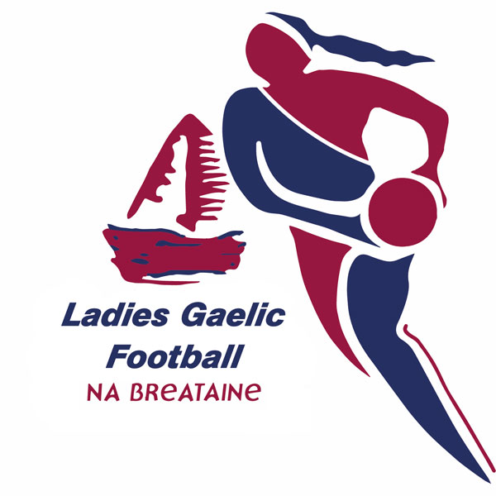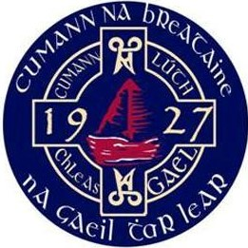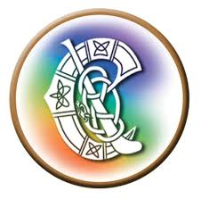

Covid-19 Update – Safe Return to Gaelic Games for the Province of Britain
16th. October 2020.

The Gaelic Games Council of Britain update on our published plan for a safe return to Gaelic games for our three organisations.

The GGCB, LGFA Council of Britain, Camogie Britain & The Provincial Council of Britain GAA Instruct all Units under their jurisdiction that all players and units in a Tier 3 lock down area are not permitted to engage in organised games or contact training of any nature.

The members of the Gaelic Games Council of Britain
Paul Foley Chairperson of GAA Britain
Karl McGuigan Secretary of GAA Britain
Martin J Brennan Chairperson of Camogie Britain
Lucy Hawkes Secretary of Camogie Britain
Patricia Morrison President of LGFA Britain
Maria Hinds Secretary of LGFA Britain

Gaelic Games for the Province of Britain 20-22 Wenlock Road London N1 7GU

